PostgreSQL Regular Exam
Exam problems for the PostgreSQL course @ Software University.
Submit your solutions in the SoftUni Judge Contest.

Bio Bakery

In a small, charming town, Oliver, an aspiring baker, sets out to open his first Bio Bakery. He needs your help as a programmer to create an efficient database to help him keep track of ingredients for his healthy pastries and manage customer service. The bakery has become a hit, offering delicious and personalized treats to the delighted community. And your partnership brings both prosperity and useful pleasures to the city.

Section 1. Data Definition Language (DDL) - (30 pts)
You've been provided with the E/R Diagram representing the Bio Bakery database, showcasing how the various entities within the Bio Bakery are interconnected. This diagram provides a visual representation of the database's structure.
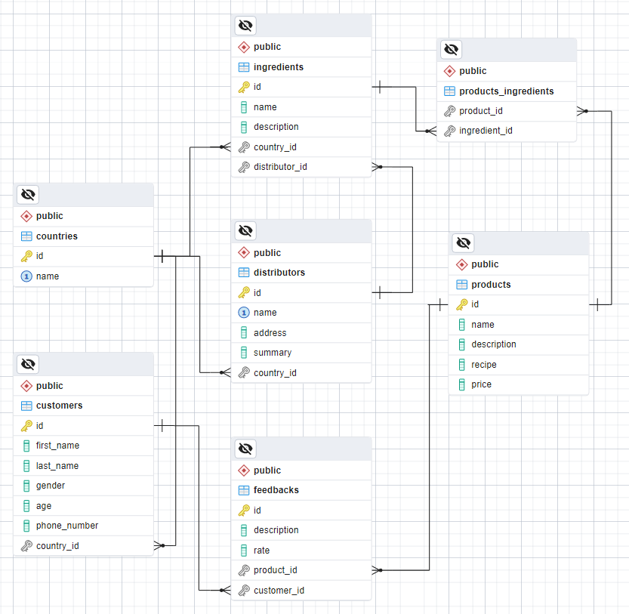
Create a PostgreSQL database named "bio_bakery_db" that comprises seven tables:
- "countries" - contains information about the place of origin (for ingredients), the central office (for distributors), or the home country (for customers);
- "customers" - stores data about our product users;
- "products" - contains information about the bakery's product offerings;
- "feedbacks" - stores details of customer feedback when evaluating certain products;
- "distributors" - contains information about organizations that supply ingredients;
- "ingredients" - holds details about fruits, vegetables, spices, and other components;
- "products_ingredients" - serves as a many-to-many mapping table linking products and ingredients;
You are assigned the responsibility of building the database tables based on the provided models:

countries
Column Name | Data Type | Constraints
id | Integer from 0 to 2,147,483,647 | Primary Key, Unique table identification, Auto-increment
name | String up to 50 symbols | It has a "UNIQUE" constraint, NULL is not allowed

customers
Column Name | Data Type | Constraints
id | Integer from 0 to 2,147,483,647 | Primary Key, Unique table identification, Auto-increment
first_name | String up to 25 symbols | NULL is not allowed
last_name | String up to 50 symbols | NULL is not allowed
gender | String limited to 1 character | The gender can only have one of two values: 'M' (for male) or 'F' (for female), NULL is permitted
age | Integer from 0 to 2,147,483,647 | The column must always have a value greater than zero  NULL is not allowed
phone_number | String limited to 10 character | NULL is not allowed
country_id | Integer from 0 to 2,147,483,647 | Relationship with table countries, Cascade Operations, NULL is not allowed

products
Column Name | Data Type | Constraints
id | Integer from 0 to 2,147,483,647 | Primary Key, Unique table identification, Auto-increment
name | String up to 25 symbols | NULL is not allowed
description | String up to 250 symbols | NULL is permitted
recipe | Text with unlimited numbers of symbols | NULL is permitted
price | Numeric number with a precision of 10 digits, including 2 digits after the decimal point | The column must always have a value greater than zero,  NULL is not allowed

feedbacks
Column Name | Data Type | Constraints
id | Integer from 0 to 2,147,483,647 | Primary Key, Unique table identification, Auto-increment
description | String up to 255 symbols | NULL is permitted
rate | Numeric number with a precision of 4 digits, including 2 digits after the decimal point | The rate is between 0 to 10, inclusive,  NULL is permitted
product_id | Integer from 0 to 2,147,483,647 | Relationship with table products, Cascade Operations, NULL is not allowed
customer_id | Integer from 0 to 2,147,483,647 | Relationship with table customers, Cascade Operations, NULL is not allowed

distributors
Column Name | Data Type | Constraints
id | Integer from 0 to 2,147,483,647 | Primary Key, Unique table identification, Auto-increment
name | String up to 25 symbols | It has a "UNIQUE" constraint, NULL is not allowed
address | String up to 30 symbols | NULL is not allowed
summary | String up to 200 symbols | NULL is not allowed
country_id | Integer from 0 to 2,147,483,647 | Relationship with table countries, Cascade Operations, NULL is not allowed

ingredients
Column Name | Data Type | Constraints
id | Integer from 0 to 2,147,483,647 | Primary Key, Unique table identification, Auto-increment
name | String up to 30 symbols | NULL is not allowed
description | String up to 200 symbols | NULL is permitted
country_id | Integer from 0 to 2,147,483,647 | Relationship with table countries, Cascade Operations, NULL is not allowed
distributor_id | Integer from 0 to 2,147,483,647 | Relationship with table distributors, Cascade Operations, NULL is not allowed

products_ingredients
Column Name | Data Type | Constraints
product_id | Integer from 0 to 2,147,483,647 | Relationship with table products, Cascade Operations, NULL is permitted
ingredient_id | Integer from 0 to 2,147,483,647 | Relationship with table ingredients, Cascade Operations, NULL is permitted

Database Design
Submit only your CREATE statements for all tables to the Judge.

Section 2. Data Manipulation Language (DML) - (10 pts)
Prior to beginning, it is necessary to import "dataset.sql". If the structure has been properly created, the data should be inserted successfully.
In this scenario, you have multiple tasks that involve manipulating the database, such as modifying data and adding new entries.

Insert
Oliver wants to celebrate the 5th anniversary of his bakery by sending presents to his valued customers. To facilitate this, he requests the creation of a new table named "gift_recipients" with the following columns:
- "id" - an automatically generated primary key;
- "name"- concatenation of customers’ "first_name" and "last_name";
- "country_id" - the country "id" of the individuals eligible to receive a gift;
- "gift_sent" - a Boolean flag with a default value of "False"
As part of the data insertion process, you should update the "gift_sent" column to "True" for customers whose country "id" matches one of the following values: 7, 8, 14, 17, 26.
To successfully accomplish the specified task, make sure to submit all SQL queries to the Judge.

Example
id | name | country_id | gift_sent
1 | Betty Wallace | 17 | true
2 | Rachel Bishop | 3 | false
3 | Joan Peters | 17 | true
4 | Jean Pierce | 8 | true
… | … | … | …
9 | Theresa Riley | 5 | false
10 | Harry Jones | 15 | false
… | … | … | …
22 | Larry Torres | 2 | false
23 | Richard Carroll | 14 | true
… | … | … | …
38 | Paula Gonzalez | 26 | true
39 | Robin Daniels | 21 | false
40 | Ashley Bryant | 4 | false

Update
In the task ahead, write an SQL query to increase "price" by 10% for products with a "rate" above 8.

Example
Before update
id | name | description | recipe | price
1 | Octinoxate | Octocrylene | Oxybenzone libero non mattis pulvinar, nulla pede ullamcorper augue a suscipit … | 13.00
2 | Tobacco Cake | Sed ante. Vivamus tortor. Duis mattis … | Aliquam augue quam sollicitudin vitae consectetuer eget rutrum … | 14.39
3 | Musaka | Praesent blandit lacinia erat … | Duis at velit eu est congue elementum. | 15.05
… | … | … | … | …
6 | Salad | Nulla ac enim.Duis aliquam convallis nunc. | Curabitur in libero ut mas | 3.31
7 | Panetone | Nulla justo. Aliquam quis turpis eget … | Morbi non quam nec dui luctus rutrum. Nulla tellus. | 8.67
… | … | … | … | …
29 | Atropinum Sulphuricum | Berberis Vulgaris | Bryonia | 1.21
30 | ALCOHOL | Suspendisse potenti. | Proin at turpis a pede posuere nonummy. Integer non velit. | 24.37
After update
id | name | description | recipe | price
1 | Octinoxate | Octocrylene | Oxybenzone libero non mattis pulvinar, nulla pede ullamcorper augue a suscipit … | 14.30
2 | Tobacco Cake | Sed ante. Vivamus tortor. Duis mattis … | Aliquam augue quam sollicitudin vitae consectetuer eget rutrum … | 14.39
3 | Musaka | Praesent blandit lacinia erat … | Duis at velit eu est congue elementum. | 16.56
… | … | … | … | …
6 | Salad | Nulla ac enim.Duis aliquam convallis nunc. | Curabitur in libero ut mas | 3.64
7 | Panetone | Nulla justo. Aliquam quis turpis eget … | Morbi non quam nec dui luctus rutrum. Nulla tellus. | 8.67
… | … | … | … | …
29 | Atropinum Sulphuricum | Berberis Vulgaris | Bryonia | 1.21
30 | ALCOHOL | Suspendisse potenti. | Proin at turpis a pede posuere nonummy. Integer non velit. | 26.81

Delete
In this task, you are responsible for cleaning up the database by removing a distributor and all related records associated with them. This task should be executed when a distributor's "name" starts with the letter 'L'.
To successfully accomplish the specified task, make sure to submit all SQL queries to the Judge.

Example
Before delete
id | name | address | summary | country_id
1 | Loride | 1 Rieder Avenue | Zero defect delivering | 23
2 | Frova | 47450 Forster Place | Configurable clear-thinking delivery | 17
… | … | … | … | …
7 | Honey 4 Kids | 249 Dexter Plaza | Customer-focused zero defect | 15
8 | Levetiracetam | 15 Arkansas Center | Enhanced attitude-oriented business | 6
9 | Rabbitbush | 1 Northfield Court | Seamless interactive transport parallelism | 5
… | … | … | … | …
20 | Allopurinol | 20 Sachtjen Drive | Multi-lateral cohesive delivery | 2
22 | Lovastatin | 8 Katie Court | Exclusive interactive transport | 16
23 | Red Zone Collection | 60 High Crossing Terrace | Synergistic actuating project | 19
… | … | … | … | …
58 | Carvedilol | 6 Mcbride Trail | Multi-layered logistical capacity | 20
59 | Lisinopril | 9503 Autumn Leaf Way | Enterprise-wide dedicated | 14
60 | M3Modulator | 68233 Division Place | Networked clear-thinking transport | 8

id | name | description | country_id | distributor_id
1 | Allspice | It is a dark-brown pea-size berry. Comes from the evergreen pimento tree. | 5 | 4
2 | Basil | Member of the mint family. It has green leaves. | 12 | 3
… | … | … | … | …
19 | Mint | One of the most popular spice used. | 20 | 15
20 | Mustard | Comes in white yellow and brown seeds. | 19 | 22
21 | Nutmeg | Oval seeds from the nutmeg tree. Dark grey color. Mace is the spice … | 7 | 22
22 | Oregano | Member of the mint family related to marjoram and thyme | 15 | 8
23 | Paprika | Powdered dried red peppers | 2 | 4
… | … | … | … | …
43 | Fenugreek | One of the most popular spice used. | 32 | 15
44 | Turmeric | Comes in white yellow and brown seeds. | 32 | 22
45 | Garifalo | Garifalo (cloves) are an important ingredient in stifado and is also used in breads … | 31 | 22
46 | Kumino | Kumino (cumin) is used in soutzoukakia, the spicey meatballs served in tomato sauce. | 31 | 8
47 | Sousami | Sousami (sesame seeds) are used on breads and in halva and with honey to make … | 31 | 4
… | … | … | … | …
50 | Mahlab | Mahlab comes from the kernel of the sour cherry. On account of its intense aroma … | 31 | 4

product_id | ingredient_id
12 | 32
8 | 11
24 | 21
29 | 26
… | …
12 | 9
18 | 22
29 | 19
… | …
13 | 10
8 | 22
10 | 25
… | …
22 | 4
After delete
id | name | address | summary | country_id
2 | Frova | 47450 Forster Place | Configurable clear-thinking delivery | 17
… | … | … | … | …
7 | Honey 4 Kids | 249 Dexter Plaza | Customer-focused zero defect | 15
9 | Rabbitbush | 1 Northfield Court | Seamless interactive transport parallelism | 5
… | … | … | … | …
20 | Allopurinol | 20 Sachtjen Drive | Multi-lateral cohesive delivery | 2
23 | Red Zone Collection | 60 High Crossing Terrace | Synergistic actuating project | 19
… | … | … | … | …
58 | Carvedilol | 6 Mcbride Trail | Multi-layered logistical capacity | 20
60 | M3Modulator | 68233 Division Place | Networked clear-thinking transport | 8

id | name | description | country_id | distributor_id
1 | Allspice | It is a dark-brown pea-size berry. Comes from the evergreen pimento tree. | 5 | 4
2 | Basil | Member of the mint family. It has green leaves. | 12 | 3
… | … | … | … | …
19 | Mint | One of the most popular spice used. | 20 | 15
23 | Paprika | Powdered dried red peppers | 2 | 4
… | … | … | … | …
43 | Fenugreek | One of the most popular spice used. | 32 | 15
47 | Sousami | Sousami (sesame seeds) are used on breads and in halva and with honey to make … | 31 | 4
… | … | … | … | …
50 | Mahlab | Mahlab comes from the kernel of the sour cherry. On account of its intense aroma … | 31 | 4

product_id | ingredient_id
12 | 32
8 | 11
29 | 26
… | …
12 | 9
29 | 19
… | …
13 | 10
10 | 25
… | …
22 | 4

Section 3. Querying - (40 pts)
Now we will perform some data extraction tasks. Please note that the example results provided in this section are based on a fresh database. It is highly recommended to clear the database that was manipulated in the previous problems from the DML section and insert the given dataset again to ensure consistency with the examples in this section.

Products
Retrieve all products with prices in the range of 10 to 20, and order the results by "price" in descending order. The required columns are "name", "recipe", and "price".

Example
name | recipe | price
Fish burger | Nulla facilisi. Cras non velit nec nisi vulputate nonu | 16.33
Rock | Duis aliquam convallis nunc. Proin at turpis a pede posuere nonummy. Integer non velit. | 15.82
Musaka | Duis at velit eu est congue elementum. | 15.05
… | … | …
Fire in kitchen | diam id ornare imperdiet | 12.10
Bread | Praesent blandit. Nam nulla. | 11.10

Negative Feedback
Select feedback records alongside the customers who provided them. Filter the feedbacks with a rating below 5.0 and customers who are females ("gender" is 'F') with an age greater than 30. Finally, order the results by "product_id" in descending order. The required columns are "product_id", "rate", "description", "customer_id", "age", and "gender".

Example
product_id | rate | description | customer_id | age | gender
27 | 4.16 | Meh.. | 20 | 57 | F
21 | 3.36 | Way too salty | 17 | 48 | F
6 | 3.60 | First food was not ok. Second I do not like sombreros. Third the music was bad. | 14 | 37 | F
5 | 0.86 | You should kill yourselves. | 26 | 47 | F

High Average Price and Multiple Feedbacks
Create an SQL query to fetch products with a price exceeding $15 and having more than one feedback. Calculate the average price for each group of products, rounding that average to two decimal places, and assign the result the label "average_price". Arrange the results in ascending order based on "total_feedbacks". In case of products having the same count of feedback, order the results by "average_price" in descending order. Include the columns "product_name", "average_price", and "total_feedbacks".

Example
product_name | average_price | total_feedbacks
Bread | 27.39 | 2
Pizza(small) | 27.27 | 2
ALCOHOL | 24.37 | 2
iloperidone | 21.86 | 2
Fried Eggs bread | 26.61 | 3

Specific Ingredients
Write an SQL query to retrieve a list of ingredients and the corresponding products that contain them, and the names of the distributors for these ingredients. The query should only include products with 'mustard'(it should be case-insensitive) in their ingredients "name" and distributors from a specific country ("country_id" = 16). Sort the results by "product_name" in ascending order.

Example
ingredient_name | product_name | distributor_name
Mustard | Musaka | Lovastatin
Mustard | Panetone | Lovastatin
Mustard | Tobacco Cake | Lovastatin

Middle Range Distributors
Select all distributors that distribute ingredients used in the manufacturing process of products with an average rating between 5 and 8 (inclusive). Order them first by "distributor_name". If there are one or more distributors with the same name, then order them by "ingredient_name". If, in the rare case, there are still duplicates, order by "product_name", all in ascending order.

Example
distributor_name | ingredient_name | product_name | average_rate
Alprazolam | Cinnamon | Nicotine Pleasure | 5.2600000000000000
Arinase | Peppercorn | Panetone | 5.4000000000000000
Capex | Clove | Root | 5.0466666666666667
… | … | … | …
Rabbitbush | Dill Weed | Banitsa | 5.5400000000000000
Rabbitbush | Marjoram | Panetone | 5.4000000000000000
Rabbitbush | Marjoram | Root | 5.0466666666666667

Section 4. Programmability - (20 pts)

Customer Feedback
You have been tasked with creating a user-defined function named fn_feedbacks_for_product() that retrieves customer feedback for a specific product. This function is designed to accept the product's name as a parameter ("product_name" of type VARCHAR(25)) and should return a table with the following columns:
- "customer_id" (INT) - representing the unique identifier of the customer who provided the feedback;
- "customer_name" (VARCHAR(75)) - denoting the first name of the customer who supplied the feedback;
- "feedback_description" (VARCHAR(255)) - describing the content or text of the feedback;
- "feedback_rate" (NUMERIC(4, 2)) - indicating the numerical rating provided in the feedback;
The results should be ordered by customer "id" in ascending order.
For this task, please only submit your user-defined function in the Judge system.

Examples
Query
SELECT * FROM fn_feedbacks_for_product('Banitsa');

Output
customer_id | customer_name | feedback_description | feedback_rate
18 | Edward | Well- it is overpriced | 5.54

Query
SELECT * FROM fn_feedbacks_for_product('ALCOHOL');

Output
customer_id | customer_name | feedback_description | feedback_rate
15 | Randy | Let's find some flavours | 8.94
23 | Richard | I did not like the product | 2.04

Query
SELECT * FROM fn_feedbacks_for_product('Bread');

Output
customer_id | customer_name | feedback_description | feedback_rate
11 | Jerry | My greetings - it could be more enjoyable if ingredients were fresh | 6.17
14 | Lisa | We had an amazing time. | 7.77
17 | Rachel | Way too salty | 3.36
22 | Larry | Total garbage food. | 1.11
30 | Amanda | Best ingredients - worst cooking | 7.23

Customer’s Country
Your final task is to create a stored procedure called sp_customer_country_name() designed to retrieve the country name associated with a given customer's full name. This procedure will take the customer's full name as input ("customer_full_name" of type VARCHAR(50)) and extract the name of the country from which they originate ("country_name" of type VARCHAR(50)).
For this task, please only submit your stored procedure in the Judge system.

Example
Query | Output
CALL sp_customer_country_name('Betty Wallace', '') | South Korea
CALL sp_customer_country_name('Rachel Bishop', '') | Japan
CALL sp_customer_country_name('Jerry Andrews', '') | Bangladesh

